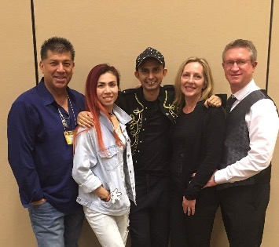
Whistle While You Work It
Choreographers: Jo & John Kinser (UK), Ruben Luna (USA),
Philip Sobrielo (Singapore), Rebecca Lee (Malaysia)
Music: Whistle (While You Work It) Katy Tiz (3:35).
Step Description: 64 Count, 4 Wall Intermediate Line Dance
Dance Turns 1/4 R. BPM: 162
Start on the Vocals, 32 counts in (0.12)

Beats Steps

1-8 R Heel Bounce X3, Kick, Behind Side Cross, Point L
1,2,3,4 Tap your R Heel X3 in place, Kick your R foot (low) to the right diagonal
5,6 Step R behind L, Step L to left
7,8 Cross R in front of L, Point L to Left

9-16 1/4 Turn Monterrey, Jazz Box 1/4 Turn
1,2 1/4 turn Left bring L next to R, Point R to Right (9:00)
3,4 Bring R next to L, Point L to Left
5,6 Cross L in front of R, Step R back
7,8 1/4 Left Stepping L in place, Step R Fwd (6:00)

17-24 Twist Heels R X2, R & L Toe Struts Back
1,2,3,4 Twist both Heels to the R, Twist Heels back to Centre X2
5,6,7,8 Touch R Toe Back, Step slight back R, Touch L Toe Back, Step slight back L

25-32 Coaster Step - Hitch, Step Fwd - Side, Twist Heels R
1,2,3,4 Step R back, Step L next to R, Step R fwd, Hitch L next to R ankle
5,6 Step L fwd, Step R to right
7,8 Twist both Heels to the Right, Twist Heels back to Centre

33-40 Fwd - Touch, 1/2 Turn - Touch, Fwd - Touch, 1/4 Turn - Touch
1,2 Step R Fwd, Touch L next to R while Snapping Right fingers
3,4 Make 1/2 Turn Left Stepping L Fwd, Touch R next to L while Snapping Right fingers (12:00)
5,6 Step R Fwd, Touch L next to R while Snapping Right fingers
7,8 1/4 Turn Left Stepping L to Left, Touch R next to L (9:00)

41-48 Step Lock Step X2, Sharp 1/2 Turn L
1,2,3,4,5,6 Step R Fwd, Lock L behind Right, Step R Fwd, Step L Fwd, Lock R behind Left, Step L Fwd
7,8 Step R fwd, Quickly Pivot 1/2 Turn L (3:00)

49-56 Bump Hips Fwd Back X2, Step Lock Step, Scuff
1,2,3,4 Bumps Hips Fwd, Back, Fwd, Back
5,6,7,8 Step L Fwd, Lock R behind L, Step L Fwd, Scuff R Fwd

57-64 V Step, Thigh Slaps X2, Clap, Flick - Touch
1,2,3,4 Step R Heel Right diagonal, Step L Heel Left diagonal, Step R back to Centre, Step L next to Right
5,6 With both Hands Slaps your Thigh X2
7,8 Clap your Hands together, Flick your R foot Back and Touch it with Left Hand

3ConCrew
jo@jjkdancin.com / www.jjkdancin.com - rsluna2@aol.com / www.n2linedance.com
sphilipg@hotmail.com / www.sphilipg.webs.com - rebecca_jazz@yahoo.com

