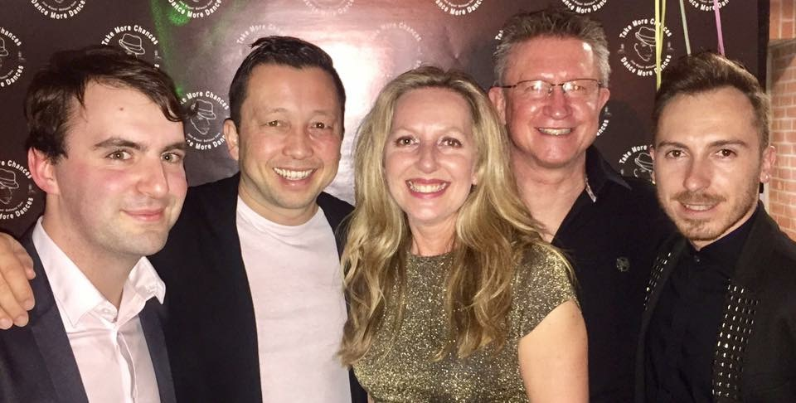
RUN ME LIKE A RIVER
4 wall line dance – Lower Advanced – 32 counts

Choreographed by: Jo Kinser, John Kinser,
Guillaume Richard, Roy Verdonk & Jef Camps

Music: “River” by Bishop Briggs
(available on itunes - 3:35 min - 62 BPM)

Intro: 16 counts

S1: SIDE, RECOVER, REVERSE FULL TURN, SIDE, BEHIND-SIDE-CROSS, SWEEP, CROSS,
SIDE, DIAG. BACK, HITCH, BACK, TOUCH, ½ REVERSE PIVOT INTO BODYROLL
1 RF step side (L toe is up) & lean R while angling body ¼ turn L (push your R hand fwd to 9:00 - chest level)
2&3 Recover on LF (straighten up to 12:00), ½ turn R & RF close next to LF, ½ turn R & LF step side
4&5 RF cross behind LF, LF step side, RF cross over LF (sweep LF fwd)
6&7& LF cross over RF, RF step side, 1/8 turn L & LF step back, hitch R
8&1 RF step back, LF touch back, make ½ turn L (weight L) & start a bodyroll backwards (facing diagonal) *Restart wall 3 (12:00)*
S2: FINISH BODYROLL, RUNS BACK INTO ROCK BACK/RECOVER, FULL TURN, SWEEP,
MODIFIED JAZZ BOX INTO SYNCOPATED WEAVE
2&3 Finish bodyroll backwards and start running back on R-L-R (still facing the diagonal, lean back on RF)
4&5 Recover on LF, ½ turn L & RF step back, ½ turn L & LF step fwd (sweep RF fwd - straighten up to 6:00)
6&7 RF cross over LF, LF step back, RF step side
&8& LF cross over RF, RF step side, LF cross behind RF
S3: SIDE (RISE), CHASSE WITH KICK, COASTER STEP WITH HITCH, BOOGIE WALKS, HITCH,
RUN BACK
1 RF big step side (rise while you reach out your RH diagonally up - lift L leg a bit)
2&3 LF step side, RF close next to LF, LF side while turning 1/8 L & kick RF fwd
4&5 RF step back, LF close next to RF, RF step fwd while hitching L (facing the diagonal)
6&7 LF step fwd, RF step fwd, LF step fwd while hitching R (styling: boogie walks - facing the diagonal)
8& RF step back, LF step back (still facing the diagonal)
S4: ROCK BACK, RECOVER, FULL TURN FWD, 1/8 SWEEP, CROSS, ¼ BACK, ¼ SIDE,
ARM MOVEMENTS, SIDE, DRAG, RUN FWD
1-2 RF rock back, recover on LF (facing the diagonal)
&3 ½ turn L & RF step back, ½ turn L & LF step fwd while sweeping RF fwd turning 1/8 turn L on LF
4&5 RF cross over LF, ¼ turn R & LF step back, ¼ turn R & RF big step side
6& Bring RH to your lips, bring LH to your lips (keeping elbows up and to the side)
7 LF big step side while dragging R towards L (drop hands)
8& RF walk forward, LF walk forward (& start moving your R-arm like a wave into the push on count 1)
Have fun!

Restart: in wall 3 you dance up to count 9, and this will be count 1 of your new wall facing 12:00, so add your arm movement and lean on count 9 to start wall 4 facing the front, so don’t start a bodyroll.

Tag/restart: after wall 6, you’ll be facing 3:00, do the first 2 counts of the dance as a little tag/restart before starting the 7th wall to 3:00.

Contact:
Jo Kinser (UK) - JoKinser@me.com
John Kinser (UK) – JohnKinser@me.com
Guillaume Richard (FR) - Cowboy_GS@hotmail.fr
Roy Verdonk (NL) - RoyVerdonkDancers@gmail.com
Jef Camps (BE) - Info@littlejeff.be

