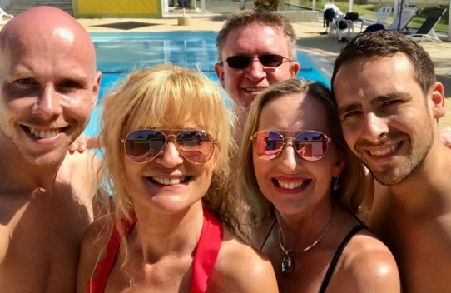
ONE DANCE

Jo & Kinser, Ivonne Verhagen, Daniel Trepat,
and Remco Zwijgers - 2018

Music: “I Wanna (One Dance) With Somebody” by Chris Mann
4 Wall Line Dance – Intermediate – 32 counts
Available on itunes – 3:45 min / 99 BPM

Jo Kinser (UK) JoKinser@me.com
Ivonne Verhagen (NL) ivonne.verhagen70@gmail.com
Daniel Trepat (NL) info@danieltrepat.com
Remco Zwijgers (NL) r_zwijgers@hotmail.com

Start on the vocals

S1: RF POINT-TOUCH-STEP, SAILOR 1/4 TURN, 3/4 TURN, SIDE-TOGETHER-SIDE-TOUCH
1&2 RF point right, touch RF next to left, RF step side right
3&4 1/4 turn left LF step behind right, RF step side right, LF step forward (9:00)
5&6 RF step forward, 1/2 turn left LF step forward (3:00), 1/4 turn left RF step side right (12:00)
&7,8 LF step next to right, RF step side right, LF touch next to right

S2: SWAY LEFT-RIGHT, ROCK-RECOVER 1/2 TURN, SWEEP 1/2 TURN, STEP, BODY ROLL
1,2 LF step side left and sway left, Recover on right and sway right
3&4 LF rock forward, recover on right, ½ turn left LF step forward (6:00)
5,6 1/2 turn left sweeping RF, RF step next to left (12:00)
7,8 Body roll from head down to toe (finish with weight on LF)

S3: WALK WALK, BALL CROSS, FORWARD, MAMBO FAN BACK, TOE FANS BACK X2
1,2 RF step forward, LF step forward
&3,4 1/8 turn left step ball of RF side right, LF cross over right, 1/8 turn right step RF forward (12:00)
5&6 LF rock forward, recover on right, LF step diagonally back left (RF toe fan right) (12:00)
7,8 RF step diagonally back right (LF toe fan left), LF step diagonally back left (RF toe fan right) (12:00)

S4: COASTER STEP, 1/4 TURN, ROCK AND CROSS, POINT RF, DRAG,
AND CROSS, UNWIND 1/2 TURN
1&2 RF step back, LF step next to right, RF step forward
3&4 ¼ turn right LF rock left, recover on right, LF cross over right (3:00)
5,6 RF point side right, RF drag towards left
&7,8 RF step behind left, LF cross over right, Unwind 1/2 turn right (weight on LF) (9:00)

Tag: NONE

Start again. Have fun!

