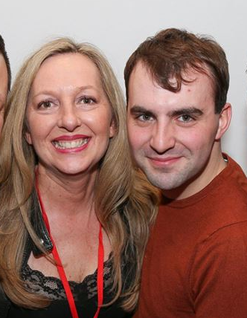

NOBODY ELSE LOVING YOU

Jef Camps (BE) & Jo Kinser (UK) - 2018

Music: “Precious” by Aston Merrygold (ft. Shy Carter)
4 Wall Line Dance – Intermediate – 32 counts (Intro 20 counts)
Available on itunes as EP – 3:45 min / 94 BPM

Jef Camps (BE) - info@littlejeff.be Jo Kinser (UK) - JoKinser@me.com

S1: RF STEP FWD, ½ BACK - SWEEP, BEHIND-SIDE-CROSS, SIDE,
RF CROSS ROCK/RECOVER, BALL, WEAVE
1-2 RF step forward, ½ turn R & LF step back while sweeping RF backwards (6:00)
3&4& RF cross behind LF, LF step side L, RF cross over LF, LF step side L
5-6& RF cross/rock over LF, Recover on LF, Step side R on ball of RF
7&8 LF cross over RF, RF step side R, LF cross behind RF

S2: BOUNCE ¾ TURN, ¼ SIDE, DIAG. HEEL-BALL-CROSS,
WALK BACK (WITH TOE FANS), LF COASTER STEP
1-2& Bounce X2 on both feet making ¾ turn L, ¼ turn L & RF step side R (6:00)
3&4 Dig L heel diagonally L forward, LF close next to RF on ball of foot, RF cross over LF
5-6 LF step back & turn R toes out, RF step back & turn L toes out
7&8 LF step back, RF close next to LF, LF step forward

S3: AND LOCK, STEP, ¼ PIVOT, CROSS, CHASSE L, SWAYS, RF COASTER
&1 RF lock behind LF, LF step forward
2&3 RF step forward, Make ¼ turn L (weight LF), RF cross over LF (3:00)
4&5 LF step side L, RF close next to LF, LF step side L
6-7 Recover on RF & Sway Hips R, Recover on LF & Sway Hips L
8& RF step back, LF close next to RF

S4: RF STEP FWD, STEP, ½ PIVOT, ½ BACK, SIDE, CROSS, LUNGE R,
¼ RECOVER, RF STEP FWD, ¾ TURN L, FLICK RF
1-2& RF step forward, LF step forward, Make ½ turn R (weight RF) (9:00)
3-4& ½ turn R & LF step back, RF step side, LF cross over RF (3:00)
5 RF step side R & lean body R while stretching L leg (knee pointed towards L diagonal)
6-7-8 ¼ turn L (weight LF), RF step forward, Make ¾ turn L (weight LF) & flick RF (3:00)

Start again. Have fun!

Tag: After wall 3 add following steps before Restarting the dance (9:00)
CHASE TURN R AND L

1-2& RF step forward, LF step forward, Make ½ turn R (weight RF)
3-4& LF step forward, RF step forward, Make ½ turn L (weight LF)

Restart: During Wall 5, dance up to count 16 and Restart the dance from the top (6:00).

