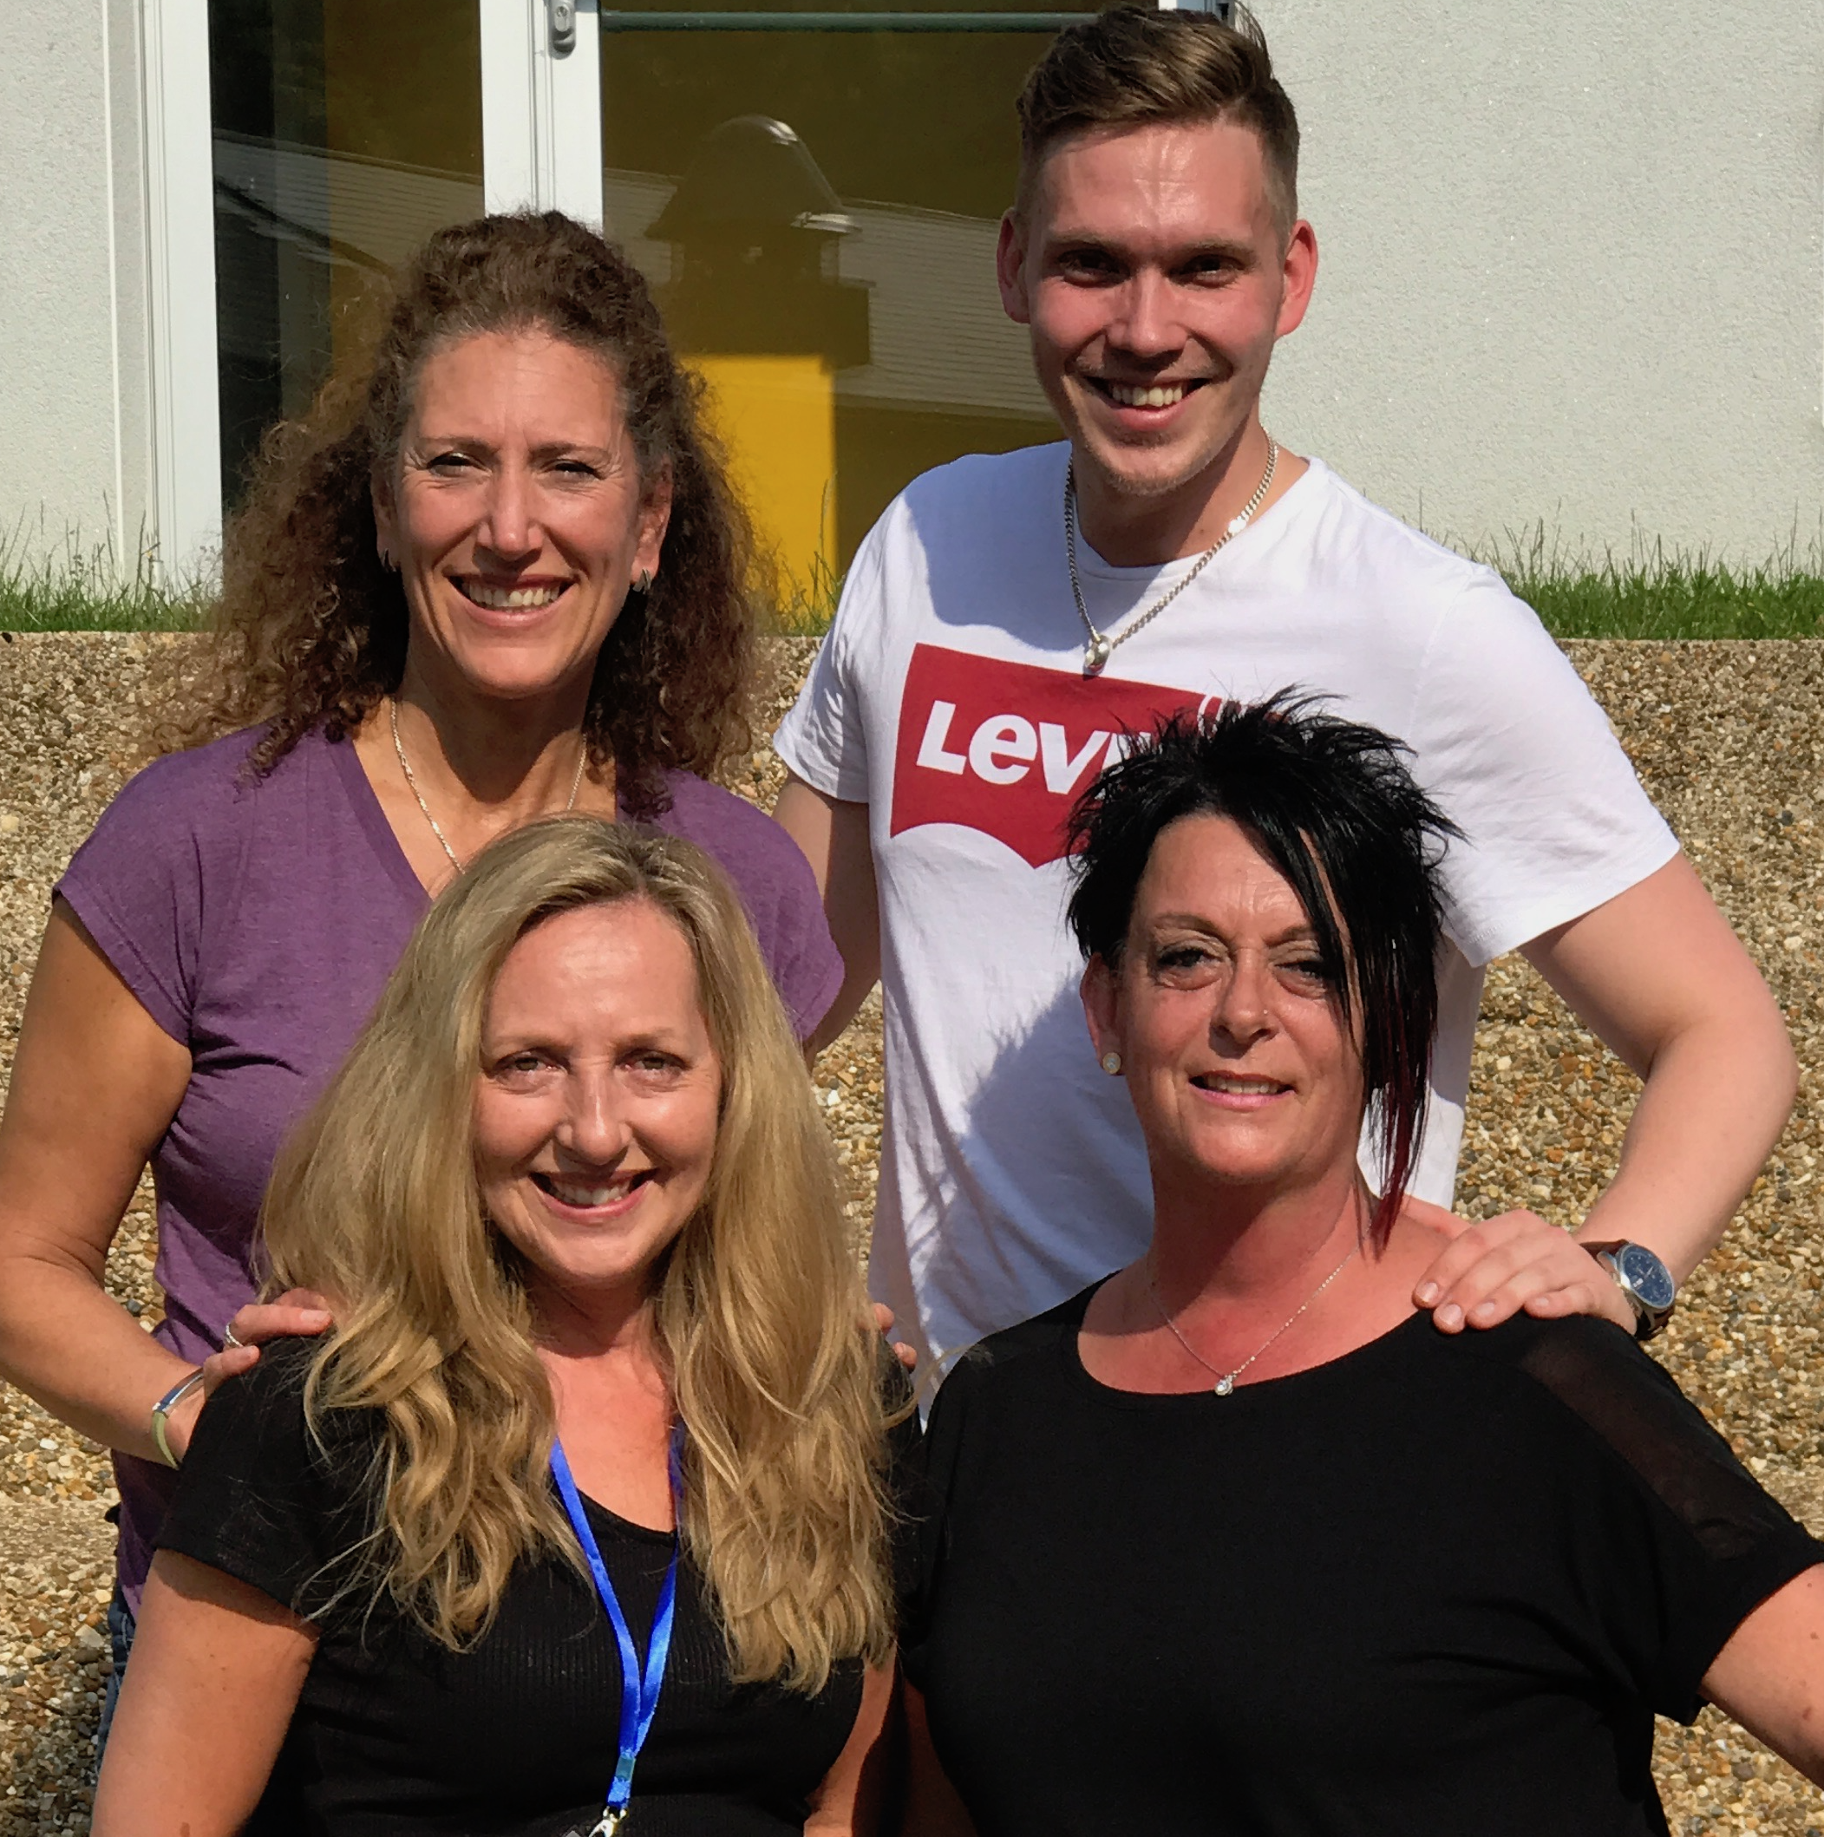
Hooked on a Feeling

2 wall Phrased line dance, Easy Intermediate Level.

Choreographed by: Dee Musk (UK), Jo Kinser (UK),
Kate Sala (UK), and Jonas Dahlgren (SE).

Music: Hooked on a Feeling – Blue Swede.
Available on itunes – 2:52 minutes.

Intro: 16 counts start on the lyrics “I can’t stop this feeling”.

INTRO 32 COUNTS only happens once

S1: Side R - Shimmy, Together - Cross Arms X2
1-4 RF step side right and Shimmy Shoulders 1-3), LF step next to right and Cross Armsin front 4)
5-8 RF step side right and Shimmy Shoulders 5-7), LF touch next to right and Cross Arms in front 8)

S2: Side L - Shimmy, Together - Cross Arms X2
1-4 LF step side left and Shimmy Shoulders 1-3), RF step next to left and CrossArms in front 4)
5-8 LF step side left and Shimmy Shoulders 5-7), RF touch next to left and Cross Arms in front 8)

S3: Forward R - Shimmy, Together - Cross Arms, Forward L - Shimmy, Together - Cross Arms
1-4 RF step forward and Shimmy Shoulders 1-3), LF touch next to right and Cross Arms in front 4)
5-8 LF step forward and Shimmy Shoulders 5-7), RF touch next to left and Cross Arms in front 8)

S4: Walk back RLRL, Sway with Arms
1-4 RF step back 1), LF step back 2), RF step back 3), LF step back 4)
5-8 Sway RLRL with Arms in front of you above your head, palms forward 8)

MAIN PHRASED ROUTINE
S1: R Dorothy, Step – Knee Pops, L Dorothy, Side – Knee Pops
1,2& RF step diagonally forward right, LF lock behind right, RF step diagonally forward right
3&4 LF step diagonally forward left, Pop both knees forward (weight on RF)
5&6 LF step diagonally forward left, RF lock behind left, LF step diagonally forward left
7&8 RF step side right, Pop both knees forward (weight on RF)

S2: L Reverse Rocking Chair, L Shuffle Back, R Rock Back
1-4 LF rock back, RF Recover, LF rock forward, RF Recover
5&6 LF step back, RF step next to left, LF step back
7-8 RF rock back, LF Recover

S3: Reverse Full Turn Box L, Stomp RF and R Fist X2, R Kickball Change
1-2 ¼ left and Step RF side right 9:00), ¼ left and Step LF side left 6:00)
3-4 ¼ left and Step RF side right 3:00), ¼ left and Step LF side left 12:00)
5-6 RF stomp up twice and at the same time Punch your right fist
7&8 RF kick forward, Step ball of RF next to left, LF step forward

PHRASING

REPEAT S1, S2,
S3: 1-10) Dance up to count 4 only. Omit R Kickball Change but Add
R Jazzbox Cross, followed X2 Stomp Ups with Fist.

REPEAT S1, S2,
S3: 1-8) Dance up to count 4, followed by R Jazzbox Cross.

TAG 1: SIDE TOUCHES, WALK AROUND ½ TURN R
1-4 RF step side right, LF touch next to right, LF step side left, RF touch next to left
5-8 Walk RLRL ½ turn over your right shoulder (6:00)

REPEAT S1, S2,

TAG 2: STEP ½ L X2, R JAZZBOX CROSS
1-4 RF step forward, ½ turn left 12:00), RF step forward, ½ turn left 6:00)
5-8 RF cross over left, LF step back, RF step side right, LF cross over right

TAG 1: SIDE TOUCHES, WALK AROUND ½ TURN R
1-4 RF step side right, LF touch next to right, LF step side left, RF touch next to left
5-8 Walk RLRL ½ turn over your right shoulder (12:00)

REPEAT from the top S1, S2,
S3: 1-10) Dance up to count 4 only. Omit R Kickball Change but add
R Jazzbox Cross, followed X2 Stomp Ups with Fist.

REPEAT from the Top S1, S2, followed by TAG 2: STEP ½ L X2, R JAZZBOX CROSS
REPEAT from the Top S1, S2, S3,
REPEAT S1, S2, S3 1-4, followed by R Jazzbox Cross. Repeat 3 times to finish the dance.

Contacts:
Jokinser@me.com
dahlgren.jonas@hotmail.com
kate_sala@hotmail.com
deemusk@btinternet.com

